Civeo’s Crisis Management Program
Building on the Making Zero Count principles of prevention and preparedness, Civeo has invested in a formal, structured Crisis Management Program (CMP). The CMP includes a series of inter-dependent systems, processes, and tools that are ready to be deployed in response to crisis events if and when they occur. Summarize below are the key components of Civeo’s CMP.
- Identification of Crisis and Emergency Scenarios
The CMP includes a list of potential crisis scenarios that are relevant to the Civeo’s operations and ranked in order of risk. The list of scenarios serves to guide crisis management planning through the identification of potential losses and impacts, response resources required, and appropriate recovery methods.
- Flexible Response Modules
Crisis and emergency response procedures are modularized within the CMP and can be combined to provide flexibility when managing complex or multiple concurrent crisis events. The modular procedures are specific and objective-oriented, allowing the Incident Management Team (IMT) the flexibility to manage and account for varying factors within individual crisis events.
- Scenario Mapping
Identified crisis scenarios are tactically mapped to potentially applicable response modules required in the management of the crisis event. Mapping facilitates the ease and swiftness of crisis response.
- Incident Command System
The Incident Command System (ICS) is an internationally recognized, standardized, on-site management system that facilitates centralized crisis management. The ICS establishes a clear line of command, integrating a combination of resources that allows the organization to quickly shift into crisis response and management.
- Activation Triggers for Scenarios
Predetermined triggers activate and coordinate various response modules in the event of a crisis situation. Activation of response modules is dependent on both the type and the severity of the event, with these triggers moving the organization into crisis management mode and activating specific response modules.
- Command Post and Backup
The Incident Command Post (ICP) is a base of operations for the Incident Commander, Command Staff, and General Staff. Identification of backup locations addresses circumstances where the primary ICP is inaccessible or its use is unfeasible.
- Communications
Communication protocols establish easily activated channels to reach all stakeholders affected by and involved in the management of the crisis. Communication plans identify the target audience, the appropriate message to be conveyed, the method of delivery, and the timeframe within which the information is to be delivered.
- Backup Resources
Critical resource stocks, including personnel and material, must be identified and made available to be deployed if necessary. Succession of delegation must also be established such that the designated delegate is prepared to assume the immediately necessary roles and responsibilities associated with a critical position.
- Regular Simulation Exercises
Simulation exercises, both scheduled and unscheduled, are to be conducted by the crisis response team and are inclusive of all parties that may participate in a crisis scenario. Additional components of the simulation exercises include regular testing of communication channels and inventorying of resources.

- Disciplined Post-Crisis Review
A post-crisis review will be conducted after each crisis event to identify gaps, follow-up actions, key impacts, and future prevention strategies. The review will seek to understand what went well and/or poorly, and the key lessons learned.

Civeo’s Incident Command System (ICS)
As referenced above, a cornerstone of Civeo’s Crisis Management Program is the Incident Command System (ICS), an international standardized approach to the command, control, and coordination of emergency response. The system provides a common hierarchy within which responders from multiple agencies can operate, integrating a combination of facilities, equipment, personnel, procedures, and communications within a common organizational structure.
Incident Management Team Functional Structure
Within Civeo’s ICS structure, an Incident Management Team (IMT) is established to execute the tactical response to any crisis. The IMT includes five major functional areas: Command, Operations, Planning, Logistics, and Finance/Administration. A sixth functional area, Intelligence/Investigations, is mobilized if required. The IMT reporting structure is illustrated below.

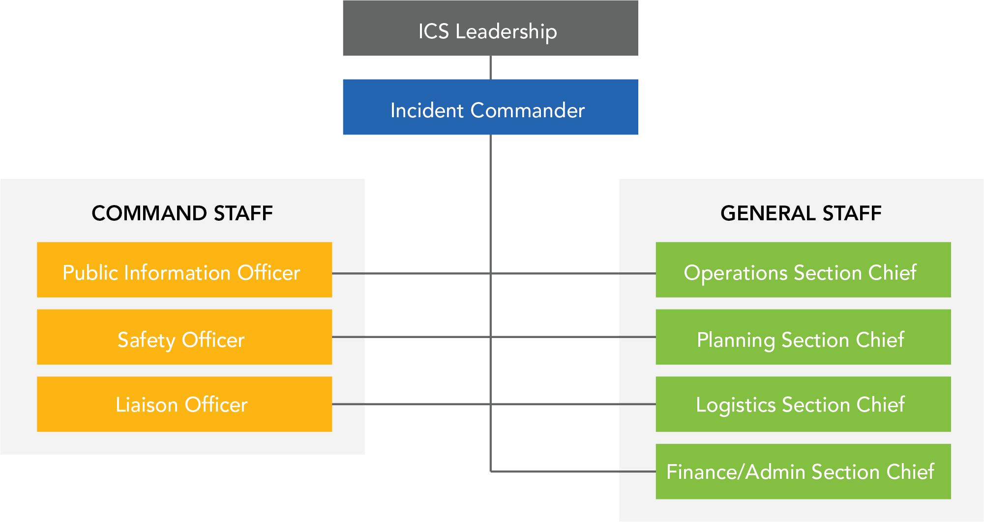

Benefits of the ICS
Standardized proven systems and structures matter when an urgent coordinated response is required. Civeo’s ICS benefits our customers by ensuring:
- Preparedness and prevention measures, in place and ready to be deployed
- Rapid, methodical intervention against external threats
- Adaptability to unique events
- Transparent stakeholder communication and engagement
- Prudent financial management of response resources

Our Experience
Our application of the ICS and our prevention and preparedness measures have served our customers and neighboring communities through a number of recent crisis events including:
- Ft. McMurray Wildfires (2016):
In May, 2016, we saw the community of Ft. McMurray experience the unimaginable. The largest wildfire evacuation in Alberta's history, with upwards of 80,000 people forced from their homes. Working within the regional ICS structure, Civeo was able to quickly transition several properties, mobilizing our operations, supply chain, and logistics infrastructure to provide meals and accommodations to thousands of people fleeing the devastation.

- Ft. McMurray Flood (2020):
In April, 2020, flood waters breached the banks of the Athabasca and Clearwater rivers displacing thousands of residents in several neighbourhoods in Ft. McMurray and the Regional Municipality of Wood Buffalo. With more than 13,000 residents displaced from their homes, Civeo worked closely with the Municipality, the Red Cross, and other local officials to provide meals and lodging to over a thousand members of the local community seeking refuge.

It should be noted that Civeo’s flood response was implemented while also managing through another crisis event: the COVID-19 pandemic. Managing two crisis events concurrently with no breaches in our on-site Pandemic Response Protocols was a significant accomplishment keeping flood refugees, guests, and staff safe.

- COVID-19 Pandemic (2020):
In early February, 2020, Civeo deployed its Incident Management Team in preparation for the onset of COVID-19, an emerging pandemic that was understood to be a significant threat to the health of our guests, staff, and the integrity of our customers’ operations.
Acting early, Civeo implemented its Pandemic Response Protocol including a detailed plan for how and when to escalate our staged response measures. The protocol was the result of a collaborative effort working in close consultation with medical professionals, government health authorities, third-party experts, and our customers.
As a testament to the credibility of our Pandemic Response Protocol, many of the measures Civeo established early in the pandemic have influenced public health guidelines in Alberta and British Columbia for the operation of workforce accommodations during a pandemic.

