Health and Safety
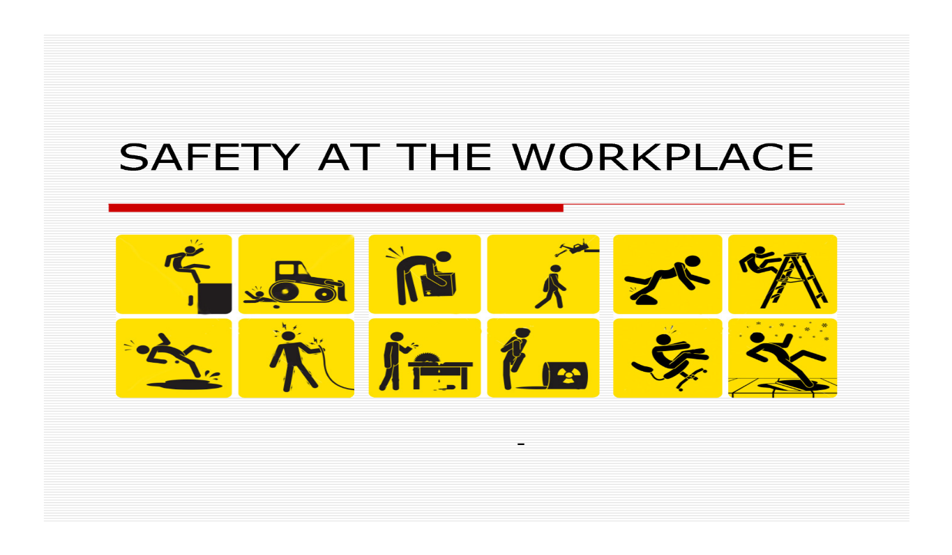
Brian Glen has led his crew of Pipefitters keeping Safety First and Foremost in their everyday work plan. Brian has not had a Recordable Incident in year following; 2016, 2017, 2018, 2019, and 2020. This is a buy into our Safety Culture with target Zero, where nobody gets hurt.
Brian always leads his crew keeping in mine Safety, Quality and Schedule; this means we work safe with quality performance the schedule will always take care of its self.
Keeping in mind, Health and Safety is one of the biggest issue of concern and it is completely the responsibility of the mangers and the business owners to provide their employees are working in safe environment. However Brian always continues to keep on motivating and boosting his trade workers to keep them active in the working process.
Brian’s goal is to ensure his workplace health and safety procedures are readily available, and know how important it is for the well-being of both employees and employers because human loss is immeasurable and intolerable. As, such loss or injuries can employ major loss to the families.
The Suncor Refinery is an industries that has many safety risks but Brian continues to devote his time to think and strategize the things that surround safety precautions and identify they are required to make sure his workers are safe at all times. With a proper balance this helps to improve the productivity and quality with safety first and foremost.

