CRAFTSPERSON OF THE YEAR AWARD
An award reserved for members of Canada’s Building Trades Unions that seeks to highlight outstanding craftsmanship, professionalism, and safety leadership of a skilled tradesperson through their performance or contribution on a maintenance job.

Brian Glen Craft Person of the Year 2021
Biography
Brian Glen is currently employed by Fluor Driver working at the Suncor Refinery in Sarnia, Ontario. He is currently a General Forman for the Pipefitter Trade.
Brian has married to his lovely wife for 10 years and together they have three beautiful children, two daughters one is 10 others is 4 and son who is 8 years old.
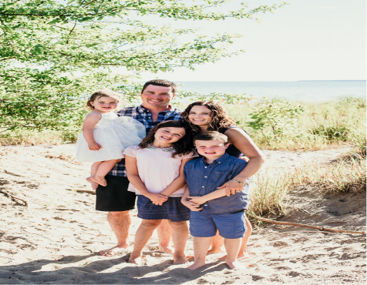

Brian grew up on a farm in the town of Mount Brydges, Ontario where he currently resides. Growing up Brian learned incredibly early in life the importance of reasonability and the importance of putting in a “hard day’s work” helping his father with assigned chores with the family farm.

Brian is a very athletic person and is a member of the Mount Brydges Hockey and Baseball Team and he also finds time to coach his son’s hockey team. Both kids are following their Dads footsteps being actively involved in sports.
Brian started his Pipefitting apprenticeship in 2001 and joined the Suncor Sarnia Refinery Team in 2012. After Brian became Journeymen, he accepted the role of a Supervisor in 2014 and later assumed the role as the Pipefitters General Foreman which is his current role.
When asked Why Should You Care?
Brian summaries that it takes an exceptional amount of time and attention to “really care,” but the results and positive impacts are well worth the effort as he has seen this firsthand for himself, knowing that people are genuine through their response when they are cared for.
Brian states when you really get down to it, being a good leader is not about your own results and your own accomplishments, it is about caring about the people you are leading. Every leader must communicate they care about their people and caring is about actions, not just words.
Further to that he said it is most important when people feel safe in their work environment, and when they feel that it is safe for them to show up and be themselves, its then they are more productive. They know it is “OK” for them to bring their concerns, their strengths, their vulnerabilities, and their creativity to their job. Trust me, you want this. And this is exactly why you ought to work hard to show you care. It is how your people will know that you have their back and that you will stand by them.
Finally, caring creates trust, and trust creates loyalty. “Proof is in the pudding,” the real worth, success, or effectiveness of something can only be determined by putting it to the test. I care and want to ensure my entire crew go home safe to their family every day.

Accomplishments
Brian has maintained an excellent relationship with Management and most important his co-workers and Supervisors. Being a great leader, it was not long before was asked to take the responsibility of a Forman and then assumed the role of a General Foreman. When Brian took the role as GF, he knew this new chapter in his life would be a challenge and moved forward to improve the Safety Culture that was present at the workplace.
Brian’s goal was to see his team succeed while adhering to “Safety, Quality and Schedule” to drive changes. In collaboration with his core team, he improved the workers “buy-in” to participate in our Safety Programs. Even with some resistance Bran pushed to improve the Safety Culture.
Brian is very rational when he is problem solving to find the root cause of issues rather than solely examining the surface. Brian indeed is an excellent leader who has pride in himself and a desire to see changes and improvements to his team.

Some examples Brian used to motivate change.
- Teamwork, Brian avoids using the word "I" instead he uses the word "we" when he refers his team.
- Utilizing communication skills effectively with Supervisors, Craft, and Staff is essential, no matter what industry you work in. Some notable communications skills we have noticed are.
- Listening; he is a good listener which is one of the best ways to be a good communicator.
- Nonverbal Communication: using his body language, eye contact, hand gestures, and tone of voice all color the messages he attempts to convey.
- Clarity and Concision; he uses good verbal communication saying just enough – don’t talk too much or too little speaking clearly and directly.
- Friendliness: using a friendly tone, a smile, he encourages workers to engage in open and honest communication, making them feel more appreciated.
- Confidence: his confidence shows workers that he believes in what he is saying and will follow through without sounding arrogant or aggressive.
- Empathy: he uses phrases as simple as "I understand where you are coming from" that demonstrates he is listening t and respect their opinions.
- Open-Mindedness: he enters conversations with a flexible, open mind and listening to and understanding the other person's point of view, rather than simply getting your message across.
- Respect: his crews are more open to communicating conveying respect for them and their ideas.
- Feedback: he provides and receives feedback appropriately, be it one on one, through email, phone calls, or weekly status updates.

Achievements/Successes/ Changes
- The Act of Vigilance Program participation have increased by 80% with expectation of one per day per worker, ensuring his team’s safety concerns have been addressed and mitigations in place.

- Reinforced the importance of the Supervisor Risk Assessment Program (JSA) and the expectation of having them in place, reviewing them daily and workers have read, acknowledged, and signed their Job Safety Analysis.

- Acknowledgment from the Client (Suncor) recognizing Brian has the ability, knowledge and skill set to replace Suncor’s Plant Coordinators when they go on an emergency leave.

- Increased Productivity was identified when Suncor adapted his ideas to improve the current Suncor Maintenance Planning Documents. Improved planning documents now included additional information which increased tool time.

- Brian’s numerous contributions to the Think Different Build Better Program have made incredibly significant and positive changes to our working environment.
When asked Brian his Future Plans?
Brian noted that not all Supervisors are born with the ability to be great leaders. Understanding the ingredients of how to become an effective leader is important when seeking to improve skills. There are predictable and correctable common mistakes that new or inexperienced Supervisors make and identifying them early on in your career is of excellent value. To succeed is to understand what is expected from employees and senior managers alike.
Brian continued to say that often many people are unprepared for their first assignment managing people and do not; identify shared challenges and solutions, draw from experience of others, learn from your own experience.

Many new Supervisors are hired or promoted because of their technical skills. Brian believes the most effective managers also are equipped with talents he refers to as “soft skills.” To be successful in the world of work, it requires being good at both technical and the soft skills, Brian says. Great supervisors can reach people and can get things done through people. With past achievements and successes and an understand how to meet the above expectations my future is to advance in a role of Superintendent and or Project manager.

Brian Glen’s
Think Different Build Better Implemented Innovations.
Please review TDBB Video below.
See Think Different Video in William Warchow Safety Leadership and Innovation Award

Brian suggested building a Lean-To Structure for the Pipefitters to help store protect assets. This improved productivity and quality having tools and equipment readily available.

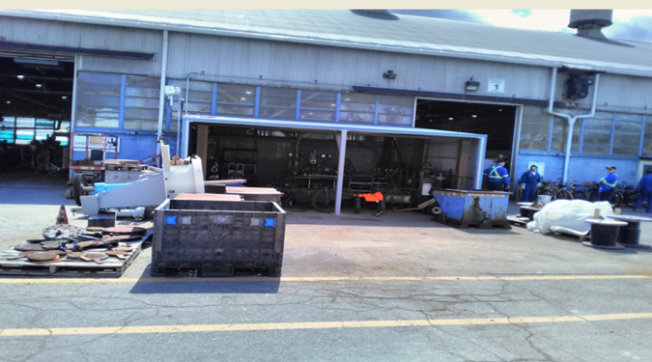

Craft must complete multiple safety documents daily and having them readily available helps the efficiency and execution of the work. Brian suggested installing multiple file folders that contain these safety documents. See photo below.

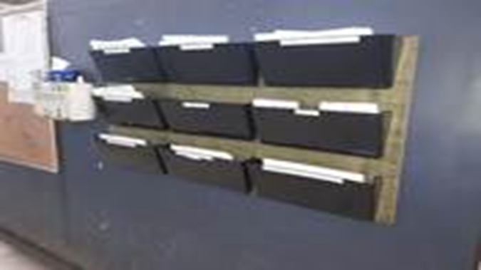

The Pipefitters would use pipe stands that were designed for fabrication of small diameter pipe. When they used the smaller pipe stands to fabricate and roll larger diameter pipe the pipe stands had the potential to shift and even move which could cause the pipe to fall. Brian suggested purchasing automated Pipe Stands that provides a solid base with no chance of the pipe to roll off. It also has an automated power roller and ability to control and adjust the height. This innovation increased productivity and provided better ergonomics for the welder resulting in better quality welds.

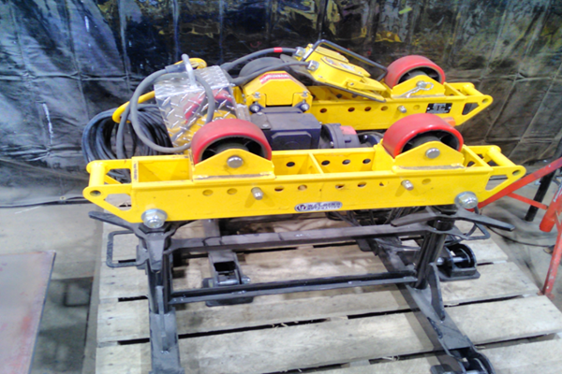

Our Pipefitters previously stored nuts, bolts and studs in their original cardboard boxes. These cardboard boxes would always break open causing the studs to fall on the shop floor causing potential slip and trip hazards. Loose nuts, bolts and studs also created an area that was very much unorganized, workers always looking for needed materials. This storage area sits back onto a main walkway in the shop increasing the hazards potential. Brian suggested having an incline racks equipped with rollers and heavy-duty plastic bins to store these nuts and bolts to keep the area more organized and professional. More important there are no nuts and studs on the floor eliminating the slip and trip hazards. See photo below.

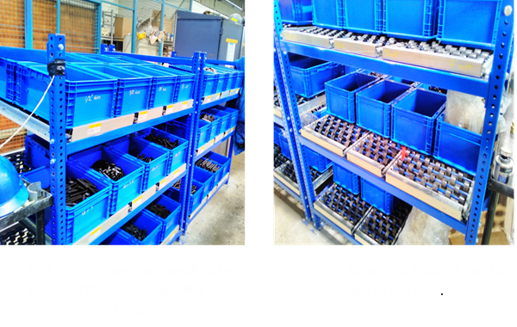
NOTE:
Please review the Think Different Build Better Video attached in the William Warchow Safety Leadership & Innovation Award. This will explain the benefits and impact of the TDBB Program and how is can drive to make positive changes in the workplace.

